Project Report On

“METAVERSE SIMULATION”

ENROLLMENT - 20103324,20103040,20103046

NAME OF STUDENTS – UDIT SHARMA, AKSHAT SINGHAL, SHREYANSH SAXENA

NAME OF THE SUPERVISOR - Mr. Janardan Kumar Verma

Panel Members- Ms. Ankita Jaiswal, Mr. Anil Mahto



MINOR PROJECT 2022

DEPARTMENT OF COMPUTER SCIENCE AND ENGINEERING

JAYPEE INSTITUTE OF INFORMATION TECHNOLOGY

NOIDA, UTTAR PRADESH

# Contents

1. Contents ………………………………………………………………………………
2. Declarations……………………………………………………………………………
3. Certificate …………………………………………………………………………….
4. Acknowledgement ……………………………………………………………………
5. Summary..…………………………………………………………………………… .
6. List of Figures…………………………………………………………………………
7. **Introduction**

**1.1 General Introduction**

**1.2 Problem Statement**

**1.3 Brief Description of Solution Approach**

**1.4 Comparison of Existing Approaches to the problem**

1. **Literature Survey**
   1. **Integrated summary of literature studied**
2. **Requirement Analysis and Solution Approach**
   1. **Overall description of the project**
   2. **Requirement Analysis**
   3. **Solution Approach**
3. **Modeling and Implementation**
   1. **Design Diagram**
      1. **Use Case Diagram**
      2. **Sequence Diagram/Activity Diagrams**
   2. **Implementation details and issues**
4. **Testing and Results**

**5.1 Testing**

**5.1.1 Testing plan**

**5.1.2 Limitations of the solution**

**5.2 Results as Screenshots**

1. **Conclusion and Future Work**
   1. **Conclusion**
   2. **Future work**

**DECLARATION**

We hereby declare that this submission is our own work and that, to the best of our knowledge and belief, it contains no material previously published or written by another person nor material which has been accepted for the award of any other degree or diploma of the university or other institute of higher learning, except where due acknowledgment has been made in the text.

..….………………………… ……………………………… …………………………….

Udit Sharma Shreyansh Saxena Akshat Singhal

(20103324) (20103046) (20103040)

Date: 30.11.2022

Place: JIIT, Noida

## CERTIFICATE

This is to certify that UDIT SHARMA(20103324), AKSHAT SINGHAL(20103040), SHREYANSH SAXENA(20103046) have successfully completed the part of project titled “METAVERSE SIMULATION” at Jaypee Institute of Information Technology under my supervision and guidance in the fulfillment of requirements of Fifth Semester, Bachelor of Technology (Computer Science & Engineering) of JIIT, Noida.

________________________

Mr. Janardan Kumar Verma

(Project Supervisor)

Date: 30.11.2022

# ACKNOWLEDGEMENT

We deem it a pleasure to acknowledge our sense of gratitude to our project guide Mr. Janardan Kumar Verma under whom we have carried out the project work. His incisive and objective guidance and timely advice encouraged us with constant flow of energy to continue the work.

We wish to reciprocate in full measure the kindness shown by Prof. Vikas Saxena (Professor & Head (CSE & IT) who inspired us with his valuable suggestions in successfully completing the project work.

Finally, we must say that no height is ever achieved without some sacrifices made at some end and it is here where we owe our special debt to our parents and our friends for showing their generous love and care throughout the entire period of time.

..….………………………… ……………………………… …………………………….

Udit Sharma Shreyansh Saxena Akshat Singhal

(20103324) (20103046) (20103040)

Date: 30.11.2022

Place: JIIT, Noida

# SUMMARY

This project was conducted under the guidance of Mr. Janardan Kumar Verma at Jaypee Institute of Information Technology. The term Metaverse was coined in a 1992 sci-fi novel, Snow Crash, where humans use avatars – virtual people – to interact with each other and also objects in the metaverse space. This futuristic notion of the metaverse is a three-dimensional digital layer – an immersion that adds to our reality.

The main window of our Metaverse consists of a 3D simulated world which consists of various 3D objects and a 3D character avatar of the user which moves with WASD keys, These are created using HTML,CSS, JAVASCRIPT, Three.js and WEBGL. There is also a Client-Server connection made through the help of Python and MQTT library and this is used to send movement data to the character avatar of the user.

We also have a setup of Arduino UNO and 6 Axis IMU (3 Axis Gyroscope and 3 Accelerometer) sensor which is coded to give data of motion for the character avatar that is sent to the Website through use of MQTT server client library for Arduino.

Our 3D world is a basic example of the endless possibilities that the Metaverse has to offer and this basic model can be used for further creation of more complicated projects in fields like games, social media, work, shopping etc.

….………………………… ……………………………… …………………………….

Udit Sharma Shreyansh Saxena Akshat Singhal

(20103324) (20103046) (20103040)

_________________________

Mr. Janardan Kumar Verma

(Project Supervisor)

Date: 30.11.2022

# 

# LIST OF FIGURES

|  |  |  |
| --- | --- | --- |
| **FIGURE NUMBER** | **FIGURE DESCRIPTION** | **PAGE NUMBER** |
| 1 | Use Case Diagram | 17 |
| 2 | Simple Accelerometer Movements | 23 |
| 3 | Roll and Pitch Measurement Using Accelerometer | 23 |
| 4 | Simple Gyroscope Measurements | 24 |
| 5 | Character Avatar of and 3D model hosted in website | 24 |
| 6 | Future Use case of Metaverse | 26 |

# **CHapter 1**

# **Introduction**

1.1 General Introduction -

**What is the Metaverse**?

The term was coined in a 1992 sci-fi novel, Snow Crash, where humans use avatars – virtual people – to interact with each other and also objects in the metaverse space. This futuristic notion of the metaverse is a three-dimensional digital layer – an immersion that adds to our reality.

Metaverse has caught the attention of everyone in the computer, software, and tech industry. It is made possible by virtual and augmented reality technology and is referred to by many experts as the next version of the internet.

A metaverse is a virtual reality simulation that can be used for various purposes, from entertainment and social networking to education and business. It is a 3D virtual world created and maintained by users and can be explored and interacted with just like the physical world. It is a hypothetical iteration of the internet as a universal and immersive virtual world focused on social connection.

1.2 Problem Statement -

We have all faced the Covid-19 Pandemic and we all had to stay isolated at home and face the restrictions. It felt a bit cooped up and suffocating at home to stay in that same limited space and see the same things everyday. But imagine if there was a World of infinite possibilities at your fingertips where you can experience and explore different things like you can travel to another country while sitting at your home or you can use and see all features of a phone you wanted to buy while relaxing on your bed or if you are a student in college and have to attend online classes, how cool it would be to make a virtual avatar and attend classes in virtual world or play games with your online friends and feel like you are actually physically present with them.

The technology used to solve real-world problems does not require innovation or out-of-the-box thinking but a radical approach that harnesses technology to bring about change. Metaverse has the capability to bring about that change, it has the ability to change the way we work, interact, consume and transact. If the virtual world experience can be immersive, inclusive, and as real as the real world, then the need for real offices, offline events, shopping malls, etc may reduce drastically thus reducing our need to commute and consume energy.

We want to take all this into consideration and create a base model for Metaverse that can be used for further advancement in different fields like gaming, fashion, travel, training etc.

1.3 Brief Description of Solution Approach -

This project aims to provide a basic model for Metaverse Simulation that can be used in various fields like games, social media, work, shopping etc.. It also shows how with comfort of home we will be able to experience infinite possibilities where you can experience and explore different things like you can travel to another country while sitting at your home or you can use and see all features of a phone you wanted to buy while relaxing on your bed or if you are a student in college and have to attend online classes, how cool it would be to make a virtual avatar and attend classes in virtual world or play games with your online friends and feel like you are actually physically present with them.

Use of Metaverse -

Metaverses are used for various purposes, including social networking, online gaming, education, and training. They can be used to create virtual worlds that are a highly interactive three-dimensional virtual world. Like the real world, users can trade land, buildings, and other digital assets in the Metaverse and explore the space using their personalized avatars. These avatars are replicas of the user that can do everything a human can do in the real world.

1. Remote Working -

The pandemic has only intensified this tendency, which has seen a significant change in the workplace in recent years. Many businesses now permit or even encourage remote work among their staff members. And while this has many benefits, there are some drawbacks as well. Maintaining communication with your team and productivity while working remotely is one of the toughest obstacles. Both of these things can be aided by the metaverse. It can be utilized for many things, such as virtual teamwork, team-building activities, etc.

1. Tourism

The pandemic undoubtedly resulted in losses and setbacks for the travel industry, but the potential of virtual travel could lead to the emergence of a brand-new tourist niche. Visitors may begin their trip planning with trip research using 5G and virtual, augmented, or mixed reality metaverse platforms before booking an in-person encounter.

It is possible to explore simulations of well-known landmarks and buildings in their original condition using the metaverse, which also offers virtual tours of real-world towns and digital representations of real estate.

1. Entertainment

The metaverse is where online entertainment is headed. The entertainment includes anything from online gaming and social networking platforms to sporting events, concerts, and television shows. Fans generally have a more intimate experience at these events because they are frequently more immersive and participatory than their real-world counterparts.

1. New Age Education

The metaverse is a media-rich setting that can serve as a hub for education. The metaverse might be a constrained learning environment that extends learning hubs. The metaverse has the potential to be one of the technologies used to increase the reach of remote learning, which is already a more widely accepted technique. To create more interesting media experiences, educational institutions can also leverage the metaverse reality.

# **CHapter 2**

# **LITERATURE SURVEY**

**2.1 Integrated summary of literature studied -**

* Web Development (HTML,CSS,JAVASCRIPT)
* 3D Environment Creation (WebGL, three.js)
* Client server connection (MQTT)
* Sensor Technology (Arduino UNO, IMU Sensor)

The main window consists of a 3D simulated world which consists of various 3D objects and a 3D character avatar of the user which moves with WASD keys. These are created using HTML,CSS, JAVASCRIPT, Three.js and WEBGL. There is also a Client-Server connection made through the help of Python and MQTT library and this is used to send movement data to the character avatar of the user.

**Web Development**

Web development, also known as website development, refers to the tasks associated with creating, building, and maintaining websites and web applications that run online on a browser. It may, however, also include web design, web programming, and database management.

Languages we have used-

1. HTML- The HyperText Markup Language or HTML is the standard markup language for documents designed to be displayed in a web browser. It can be assisted by technologies such as Cascading Style Sheets (CSS) and scripting languages such as JavaScript.

ii) CSS - Cascading Style Sheets (CSS) is a simple mechanism for adding style (e.g., fonts, colors, spacing) to Web documents. It describes how HTML elements should be displayed. for example, to alter the font, color, size, and spacing of your content, split it into multiple columns, or add animations and other decorative features.

iii) JAVASCRIPT - JavaScript (JS) is a lightweight, interpreted, or just-in-time compiled programming language with first-class functions. While it is most well-known as the scripting language for Web pages, many non-browser environments also use it, such as Node.js, Apache CouchDB and Adobe Acrobat. JavaScript is a prototype-based, multi-paradigm, single-threaded, dynamic language, supporting object-oriented, imperative, and declarative (e.g. functional programming) styles.

**3D Environment Creation-**

1. WEBGL - WebGL (Web Graphics Library) is a JavaScript API for rendering high-performance interactive 3D and 2D graphics within any compatible web browser without the use of plug-ins. The real significance of WebGL is that the performance is very good for real-time graphics. It also has provisions for the usage of the GPU, which means that we can create games, visualizations, effects, etc., all inside the browser.

ii) Three.js - JavaScript 3D library The aim of the project is to create an easy to use, lightweight, cross-browser, general purpose 3D library. The current builds only include a WebGL renderer but WebGPU (experimental), SVG and CSS3D renderers are also available in the examples.

**Client Server Connection-**

Client-server denotes a relationship between cooperating programs in an application, composed of clients initiating requests for services and servers providing that function or service.

1. MQTT - MQTT is an OASIS standard messaging protocol for the Internet of Things (IoT). It is designed as an extremely lightweight publish/subscribe messaging transport that is ideal for connecting remote devices with a small code footprint and minimal network bandwidth. MQTT is used in variety of industries.

**Sensor Technology -**

Sensors have a very wide range, and there are many types, but fundamentally, sensors are devices that detect the feature quantity of a measurement object and convert this quantity into a readable signal, which is displayed on an instrument. Sensing technology, simply put, is a technology that uses sensors to acquire information by detecting the physical, chemical, or biological property quantities and convert them into readable signal.

1. Arduino UNO- Arduino is the open-source platform used for making custom electronics projects.The data signal runs from the sensor to the output pins of the Arduino. The data is further recorded by the Arduino
2. IMU Sensor - it is a specific type of sensor that measures angular rate, force and sometimes magnetic field. IMUs are composed of a 3-axis accelerometer and a 3-axis gyroscope, which would be considered a 6-axis IMU. They can also include an additional 3-axis magnetometer, which would be considered a 9-axis IMU. Technically, the term “IMU” refers to just the sensor, but IMUs are often paired with sensor fusion software which combines data from multiple sensors to provide measures of orientation and heading.

# **CHapter 3**

# **Requirement Analysis and Solution Approach**

**3.1 Overall description of the project -**

Metaverse is defined as a collective virtual shared space, created by the convergence of virtually enhanced physical reality and virtual space including the sum of all virtual worlds like augmented reality, virtual reality and the Internet. The word “metaverse” includes “meta” (meaning beyond) and “universe”; the term is used to describe the concept of a future iteration of the Internet.

The Covid-19 pandemic has accelerated innovation in educational field and has provided both new challenges and opportunities for education. Online education and virtual academic conferences have been on the rise since the outbreak of the pandemic.

science fiction author Neal Stephenson coined the term metaverse in his 1992 novel Snow Crash. In the book, human avatars and software agents interact in a three-dimensional virtual space.

In our project the User will get an avatar character which he will be able to move with the help of WASD and arrow keys or with the help of data sent through the Server Device through the help of MQTT and Python.  
Data is also sent by the IMU sensor to Arduino UNO and then it sends data to the host website through MQTT server.

The 3d world is a basic example of the endless possibilities that the Metaverse has to offer and this basic model can be used for further creation of more complicated projects in fields like games, social media, work, shopping etc.

**3.2 Requirement Analysis -**

* The User should be able to start the host website.
* The User should be able to move the Avatar with the help of WASD keys.
* The MQTT server should be able to connect to the website client.
* Data Sent by MQTT server should be received by the website client.
* Proper connection should be made between IMU and Arduino UNO.
* IMU sensor tracked data should be correctly send to Arduino UNO and then to the Website Client through the MQTT server for Arduino.
* The Avatar should move after website receives data from user through sensor or through python program.

**3.3 Solution Approach -**

In our project the User will get an avatar character which he will be able to move with the help of WASD and arrow keys or with the help of data sent through the Server Device through the help of MQTT and Python.  
Data is also sent by the IMU sensor to Arduino UNO and then it sends data to the host website through MQTT server.

The 3d world is a basic example of the endless possibilities that the Metaverse has to offer and this basic model can be used for further creation of more complicated projects in fields like games, social media, work, shopping etc.

This project aims to provide a basic model for Metaverse Simulation that can be used in various fields like games, social media, work, shopping etc.. It also shows how with comfort of home we will be able to experience infinite possibilities where you can experience and explore different things like you can travel to another country while sitting at your home or you can use and see all features of a phone you wanted to buy while relaxing on your bed or if you are a student in college and have to attend online classes, how cool it would be to make a virtual avatar and attend classes in virtual world or play games with your online friends and feel like you are actually physically present with them.

# **CHapter 4**

# **Modeling and IMPLEMENTATION**

**4.1 Design Diagram**

**4.1.1 Use Case Diagram**

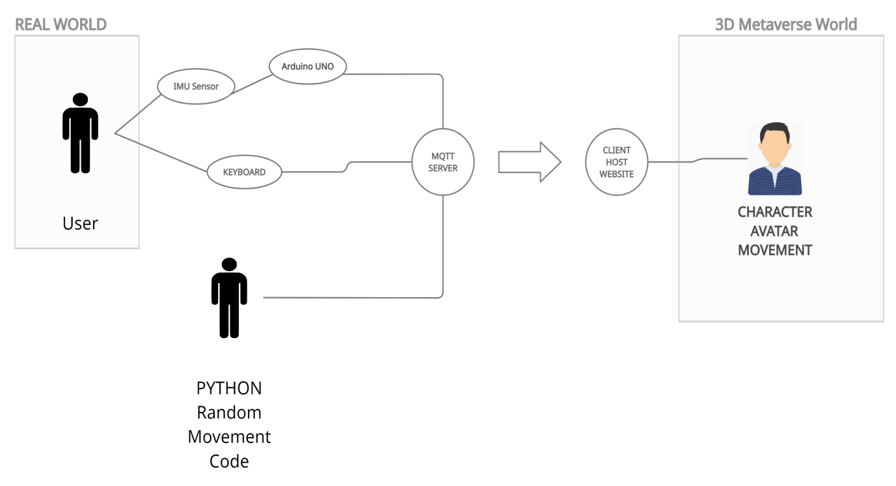

Fig. 1 - Use Case Diagram

**4.2 Implementation Details**

Metaverse is defined as a collective virtual shared space, created by the convergence of virtually enhanced physical reality and virtual space including the sum of all virtual worlds like augmented reality, virtual reality and the Internet. The word “metaverse” includes “meta” (meaning beyond) and “universe”; the term is used to describe the concept of a future iteration of the Internet.

**Features Build, Language Used -**

* Web Development (HTML,CSS,JAVASCRIPT)
* 3D Environment Creation (WebGL, three.js)
* Client server connection (MQTT)
* Sensor Technology (Arduino UNO, IMU Sensor)

The main window consists of a 3D simulated world which consists of various 3D objects and a 3D character avatar of the user which moves with WASD keys. These are created using HTML,CSS, JAVASCRIPT, Three.js and WEBGL. There is also a Client-Server connection made through the help of Python and MQTT library and this is used to send movement data to the character avatar of the user.

The User will get an avatar character which he will be able to move with the help of WASD and arrow keys or with the help of data sent through the Server Device through the help of MQTT and Python.

The 3d world is a basic example of the endless possibilities that the Metaverse has to offer and this basic model can be used for further

creation of more complicated projects in fields like games, social media, work, shopping etc.

The User will start the host website and should be able to move the Avatar with the help of WASD keys.The MQTT server is connected to the website client. Data Sent by MQTT server is received by the website client. Proper connection is also made between IMU and Arduino UNO and IMU sensor tracked data is correctly send to Arduino UNO and then to the Website Client through the MQTT server for Arduino. The Avatar should move after website receives data from user through sensor or through python program.

# **CHapter 5**

# **Testing and results**

**5.1 Testing**

**5.1.1 Testing plan**

|  |  |  |  |
| --- | --- | --- | --- |
| **Types of Testing** | **Will the Test Be Performed** | **Explanation** | **Software Components** |
| **Requirement Testing** | **Yes** | **Whether project requirements are feasible or not in term of time and resources** | **All components** |
| **Unit Testing** | **Yes** | **Testing of individual modules** | **All components** |
| **Regression Testing** | **Yes** | **Testing an application as a whole** | **All components** |
| **Interface Testing** | **Yes** | **Testing whether the user interface is user friendly or not** | **All components** |
| **Stress Testing** | **Yes** | **Checking when and how system fails** | **All components** |
| **Comparison Testing** | **Yes** | **To compare inc/dec in performance** | **All components** |
| **Security Testing** | **Yes** | **Whether user data is secure or not** | **All components** |
| **Load Testing** | **Yes** | **Maximum workload system can handle** | **All components** |
| **Volume Testing** | **Yes** | **Behaviour and response time of application** | **All components** |

**5.1.2 Limitations of the solution**

The promises and possibilities of the metaverse are enormous – and many companies are developing apps, products, and services to help develop the metaverse and to serve its users in a more immersive digital world. But there is a darker side to the metaverse, so we need to look at some of the challenges this incredible technology will bring.

Here are the seven biggest challenges of the metaverse that I see right now.

1. Privacy Issues

The metaverse is the next version of the internet, and we use technology like augmented and virtual reality to immerse ourselves in the digital world. With all this digitization comes privacy challenges. We already have privacy concerns when we browse the web. The technology that is already tracking our behavior online will also exist in the metaverse, and the tracking is likely to become even more invasive and intense. For example, VR-headsets will include eye-tracking technology, so marketers and advertisers could potentially see from our headset data where exactly we are looking in our immersive experience, and for how long. This is a marketer’s dream, of course, but is a major concern to anyone who is concerned about their privacy. Companies will also be able to monitor our physical reactions as we link to wearable and haptic devices that measure our emotions and physical reactions. Enormous amounts of data could be collected and used by companies for marketing or other purposes.

1. Protecting Our Kids As parents,

it’s already difficult to track what our kids are doing online, and that challenge will continue with the metaverse. Understanding what our kids are doing in the metaverse will be even more challenging, because we can’t see the world they’re looking at in their VR headset, and there is no process in place for monitoring their screens using tablets or phones.

3. Health Concerns

VR “hangovers” are a known phenomenon, and people can also experience post-VR sadness. When we have experienced an amazingly immersive world and have to come back into the real world, it can make us depressed and sad – and the more incredible our immersive experiences become, the more people will struggle with this. Internet or gaming addictions are already a big problem for kids and adults, and getting hooked on spending all our time in the metaverse could be an even greater problem in the future.

1. Access Inequality

In order to use augmented reality, we need the latest smartphone and handset technology, and VR experiences require high-tech, expensive headsets as well as strong and reliable connectivity. How can we make sure that everyone in the world has equal access to the metaverse, and not just the people who have the most money and live in advanced countries? We will need to come up with plans to increase access to the metaverse as these immersive experiences become more and more important.

1. Metaverse Laws Can a virtual act be a crime?

The metaverse will bring regulatory challenges and will introduce new gray areas in many laws. For example, if you are in virtual reality and you are wearing a haptic suit, and someone in the virtual world touches you without your permission, how is this different from an assault in the real world? We will need to face these regulatory challenges as technology advances and thorny legal issues emerge.

1. Desensitization

Many people will be playing violent games in VR, where you can touch and feel what you’re doing. These immersive experiences will feel very real and could lead to people becoming desensitized to their behaviors. In a game, if you are shooting a gun at someone or strangling that person, I believe there is a real risk that people will become more likely to replicate that behavior in the real world due to VR desensitization.

1. Identity Hacking In the virtual world,

we will be using avatars – and it will be possible for people to hack our avatars and steal our online identities. If this happens, the hacker could pretend to be you and could wreak havoc in your virtual and real worlds.

**5.2 Results as Screenshots-**

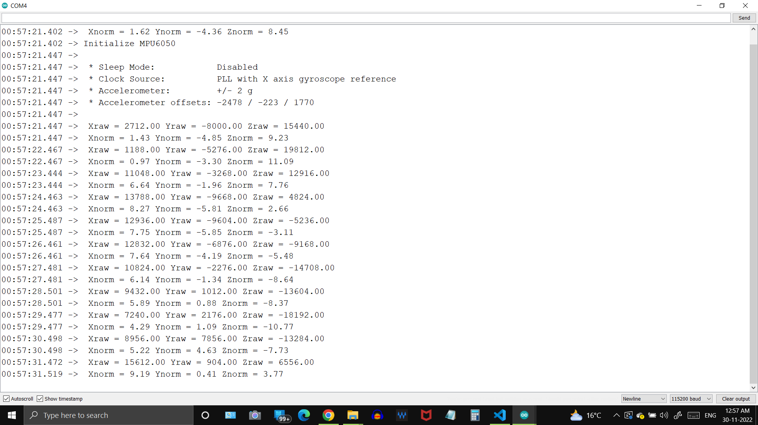

Fig.2 Simple Accelerometer Measurements

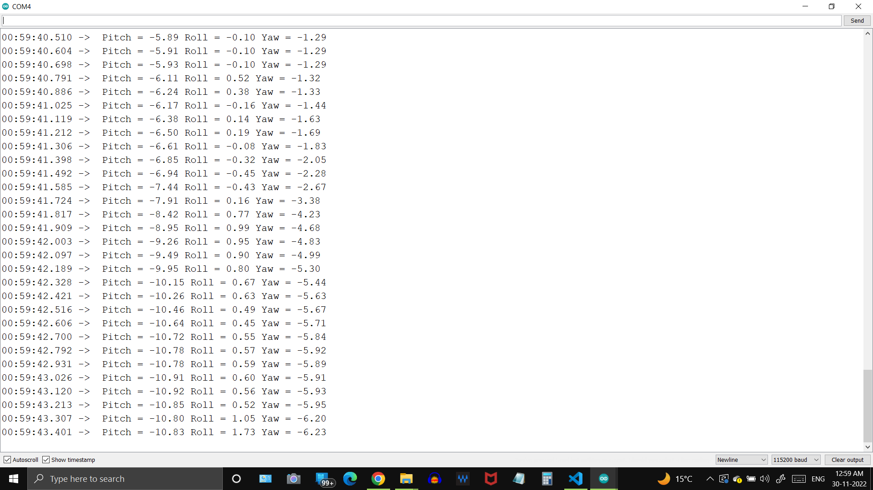

Fig.3 Roll and Pitch Measurement Using Accelerometer

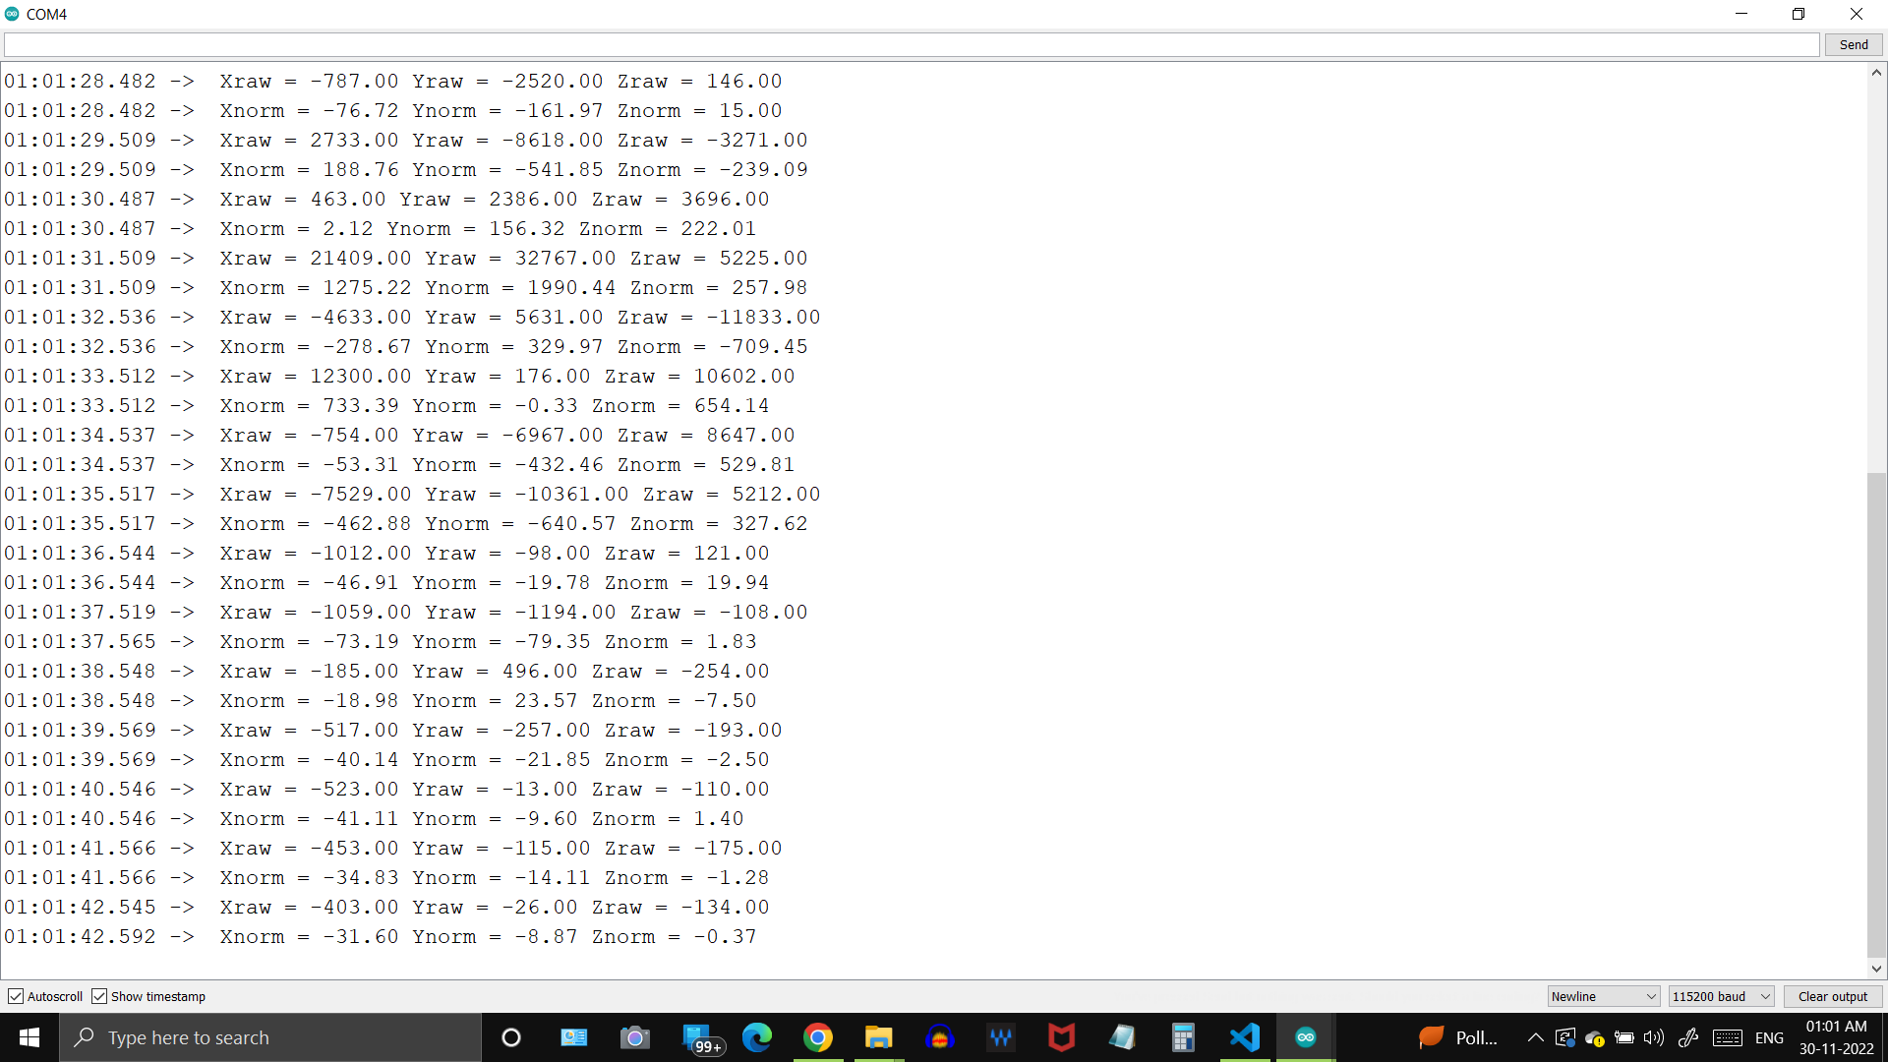

Fig.4 Simple Gyroscope Measurements

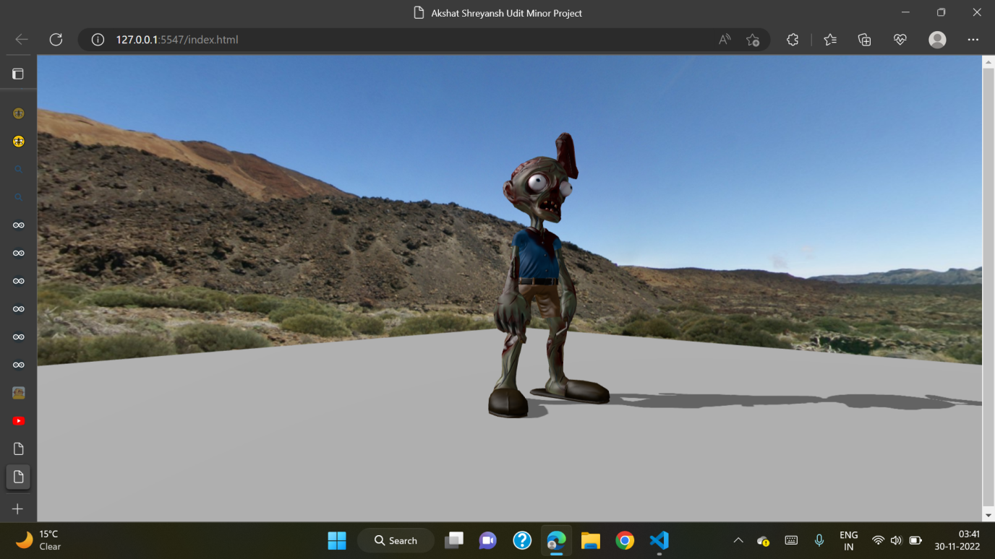

Fig.5 Character Avatar of and 3D model hosted in website

# **CHapter 6**

# **Conclusion and future work**

**6.1 Conclusion -**

This project aims to provide a basic model for Metaverse Simulation that can be used in various fields like games, social media, work, shopping etc..

It also shows how with comfort of home we will be able to experience infinite possibilities where you can experience and explore different things like you can travel to another country while sitting at your home or you can use and see all features of a phone you wanted to buy while relaxing on your bed or if you are a student in college and have to attend online classes, how cool it would be to make a virtual avatar and attend classes in virtual world or play games with your online friends and feel like you are actually physically present with them.

This all can be made possible with help our project as a base for further advancements in different fields.

* 1. **Future work -**

As the metaverse concept is starting to incorporate Web3 technology enabled through blockchain technology, the future metaverse would be something very similar to our real world in many aspects and even replace some real-world activities.

Already some metaverse non-fungible token (NFT) vendors have enabled their NFTs to be usable in some metaverse games such as clothing and footwear and more are planning to venture into the domain.

Future Use of our Work -

Metaverse can used for various purposes, including social networking, online gaming, education, and training. They can be used to create virtual worlds that are a highly interactive three-dimensional virtual world. Like the real world, users can trade land, buildings, and other digital assets in the Metaverse and explore the space using their personalized avatars. These avatars are replicas of the user that can do everything a human can do in the real world.

Our project can act as a base and be used for further advancements and following fields -

1.Remote Working

2.Tourism

3.Entertainment

4.New Age Education

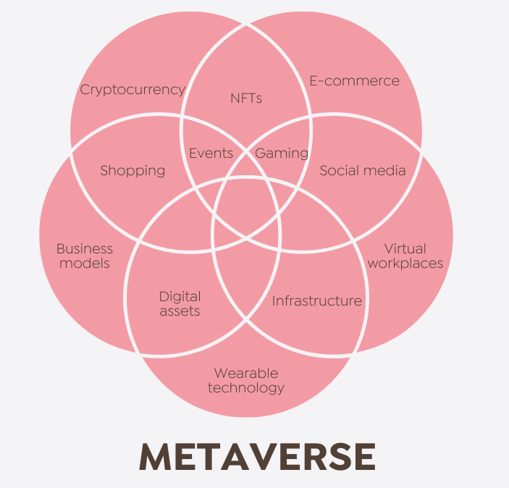

Fig.6 Future Use case of Metaverse